Homework for Chapter 6: Causal Diagrams

1. In a conversation with your friend, you mention a study you read that found that being tall causally makes you more likely to earn above $100,000 per year. Your friend says the study must be wrong, since they know several tall people who make much less than that, and several short people who do earn that much. Does your friend’s reasoning make sense or not, and why?

Answer: My friend’s reasoning may make sense in some fields. But it might

not make sense in social science. The study that being tall causally makes people more likely to earn above 100,000 per year means that being tall could change the probability of earning above 100,000 per year. Though several tall people who make much less than that and several short people who do earn that much, the appearance of these examples does not mean that the study is wrong because the “causally” here means that being tall can change the probability of earning 100,000 per year.

1. Consider the below diagram, which reproduces Figure 6.3:  
   Diagram

   Description automatically generated  
   In this diagram...
   1. Which variables have a direct effect on Money?

Answer: TerryInRoom and CoinFlip.

* 1. Which variables have an indirect effect on Money?

Answer: Terry’sMood.

1. You are interested in the question “Does reading Harry Potter as a child make you read more as an adult?” and draw the diagram below.   
   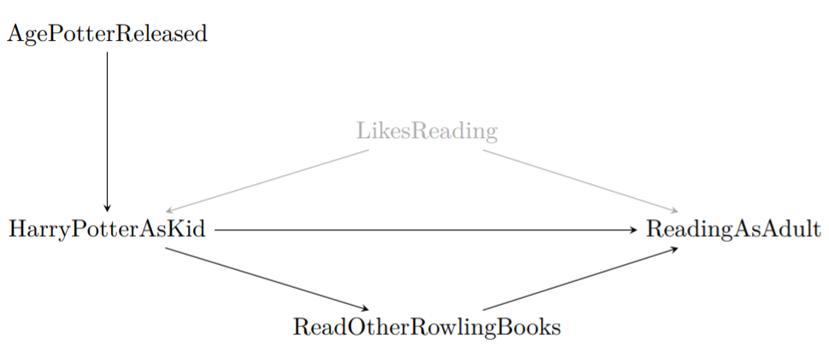
   1. What direct effects should be included when trying to answer your research question of interest?

Answer: The effect of HarryPotterAsKid on ReadingAsAdult (HarryPotterAsKid→ReadingAsAdult); the effect of ReadOtherRowlingBooks on ReadingAsAdult (ReadingOtherRowlingBooks→ReadingOtherRowlingBooks); the effect of LikesReading on ReadingAsAdult (LikesReading→ReadingAsAdult); the effect of LikesReading on HarryPotterAsKid (LikesReading→HarryPotterAsKid); the effect of HarryPotterAsKid on ReadOtherRowlingBooks (HarryPotterAsKid→ReadingOtherRowlingBooks).

(The variable AgePotterReleased has a direct effect on HarryPotterAsKid but has an indirect effect on ReadingAsAdult via HarryPotterAsKid.)

* 1. What indirect effects should be included when trying to answer your research question of interest?

Answer: first, the effect of HarryPotterAsKid on ReadingAsAdult via ReadOtherRowlingBooks; second, the effect of AgePotterReleased on ReadingAsAdult via HarryPotterAsKid; third, the effect of AgePotterReleased on ReadingAsAdult via HarryPotterAsKid and ReadingOtherRowlingBooks; forth, the effect of LikesReading on ReadingAsAdult via HarryPotterAsKid.

* 1. What is a likely alternative explanation of why we might see a relationship between reading Harry Potter and reading more as an adult?

Answer: The characteristics of enjoying reading might be an alternative explanation of the relationship between reading Harry Potter as kid and reading more as an adult. If people enjoy reading, they will be more likely to read Harry Potter as kid and be more likely to read more as an adult too. The characteristics of enjoying reading might give a boost to both reading Harry Potter as kid and reading more as an adult. So it can be an alternative explanation of the relationship between reading Harry Potter as kid and reading more as an adult.

1. The figure in Question 3 has LikesReading included as an unobserved variable. In a few sentences each, explain:
   1. Why do we bother to include variables on our diagrams if we can’t observe them?

Answer: There are two reasons why we include unobserved variables in diagrams: first, the unobserved variables could be key parts of the data generating process; second, they can sometimes fill in for variables that we know must be there, but we have no idea what they are (latent variables). For example, for two correlated variables, we know that there must be a latent variable that causes both of them but for now we have no idea what it is.

* 1. Why might we think that LikesReading is an unobserved or latent variable?

Answer: First, this variable is hard to be measured or observed. It is a little bit hard for us to know about whether people enjoy reading and it is hard for us to quantify/measure how much people enjoy reading. Besides, this variable can cause both HarryPotterAsKid and ReadingAsAdult. So it might be the latent variable that makes HarryPotterAsKid and ReadingAsAdult correlated.

1. Consider the research question “do government fire-safety advertisements reduce forest fires?”. ‘
   1. Draw a causal diagram with these features: (a) ForestFires is caused by FireSafetyAds and ParkRangers (who can help catch fires early and put them out). (b) Both FireSafetyAds and ParkRangers are caused by GovtBudget (the government has to pay for this stuff!). (c) GovtBudget is caused by TimeSinceLastFire— a recent fire might get more money sent to the parks department.

* 1. Suggest one omitted arrow or variable that should be on the diagram.

The variable of the outcome of the last fire might affect fire-safety ads. If the last fire causes devasting outcome, there might be more fire-safety ads.

1. Think of a research question in your field/major.
   1. Sketch out the possible data generating process.

Answer:

Do longer quarantine days make people feel more negative toward government during the pandemic?

The longer quarantine periods make people feel more negative toward the government during the pandemic. The number of infected patients will affect the number of quarantine days. The number of infected patients will also affect people’s attitude toward the government. The more people are infected, the more negative people feel toward the government. Whether the cost of quarantine is covered by national health care will affect people’s attitude toward the government. The Gross Domestic Production growth rate will also affect the number of quarantine days. If GDP growth rate experiences a great downturn, the quarantine period will be shorter. The GDP growth rate will also affect people’s attitude toward the government. The lower the GDP growth rate is , the more negative people feel toward the government.

* 1. What is the cause of interest? The outcome?

Answer: the cause of interest: the number of quarantine days; outcome: people’s attitude toward the government.

* 1. What other variables are in play?

Answer: the number of infected patients, national health care coverage, and GDP growth rate

* 1. Draw a causal diagram depicting the relationships between all of the variables?

* 1. Can there be any unobserved or latent variables? Include them in the diagram.

There are two unobserved variables: health care policies and nationalism education.

1. Consider this research question: Does the inclusion of “free shipping” cause people to buy items from an online store more?
   1. List six variables that should be included in a causal diagram.

Variables: Free Shipping; Buying Items From Online Stores; Income; The Distance Of Shipping; Location; LikesOnlineShopping.

* 1. Is it feasible to collect data on all the variables that you listed in part a? Can the variables be measured easily?

It is not always feasible to collect data on all the variables. Some people might not be willing to tell others their income and their locations to protect their privacy. Besides, the variable LikesOnlineShopping, to what extent people like online shopping, is a little bit hard to be measured.

1. Define *causality*. In a few sentences, why is causality interesting and important?

The concept of causality means that the change of the value of X will lead to the change of the distribution of Y. The change of the distribution of Y is the result of the change of the value of X. Learning about causality could help us understand DGPs and our research questions better since many research questions are causal in nature.

1. Which of the following describes a representation of a data generating process (DGP) including variables in that DGP and the causal relationships between them?

Answer: d. Causal diagram

* 1. Causality
  2. Direct and indirect effect
  3. Latent variable
  4. Causal diagram